NOVEMBER 2021

COVID'S IMPACT ON MENTAL HEALTH
A newsletter from Nexim Healthcare Consultants Inc

What's inside this issue:

Changes
Brought By Covid-19

The Effects of Covid-19 And the Pandemic

Changes Brought by Covid-19

Written by Nexim

The working environment of workers, especially essential, has been increasingly unsafe during the advent of the pandemic. Due to the physical situation, they usually work in, they are unable to practice social distancing and other safety measures brought abruptly by the lockdown. As a result, they live cautiously as they have higher chances of contracting the diseases from others and transmitting them to live-in family and friends. Notably, essential workers have been found to have difficulty affording necessities that may inflict mental health.

Throughout the pandemic, many people across the country have experienced job or income loss, which has generally affected their mental health.

"The effects are also greater among certain groups. People on lower incomes, those who work in frontline professions, and people of color are more likely to be under threat of reduced income and exposure to COVID-19 infection, which contributes to stress and reduced well-being.”

- Martin Hagger, PhD
Professor of Health Psychology, University of California, Merced and Professor of Behavior Change, University of Jyväskylä, Finland

The Effects of Covid - 19

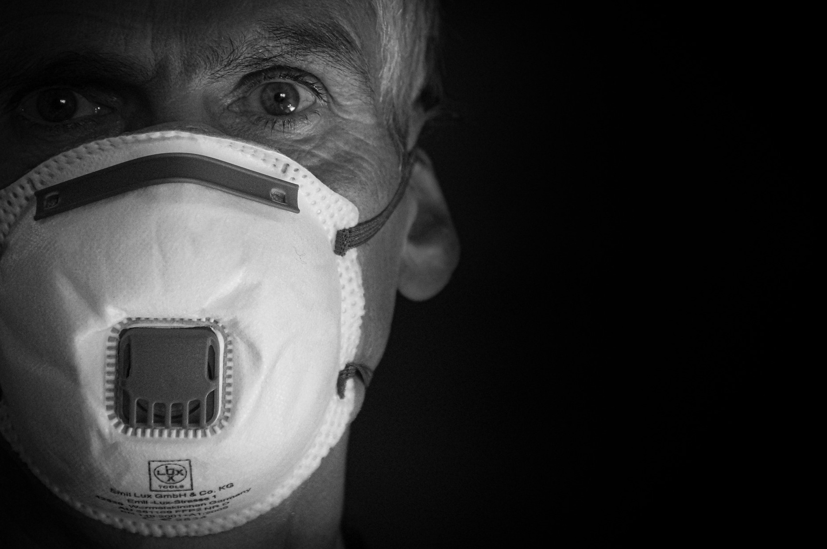
COVID-19 is having a huge negative impact on Canadians’ mental health, with many seeing their stress level doubling ever since the pandemic. People are struggling with fear of uncertainty about their own health and loved ones' health, concerns about employment and finances, and social isolation.

A recent poll found that 50% of Canadians reported worsening mental health since the pandemic began with many feeling worried (44%) and anxious (41%).6 One in 10 Canadians polled said that their mental health had worsened ‘a lot’ as a result of COVID-19.7 Similar results were found in a survey of Canadian workers, where 81% reported that the pandemic is negatively impacting their mental health, indicating a significant drop in overall worker mental health since the beginning of COVID-19.
Because of the Covid-19 Pandemic, there’s been a severe decrease in mental health, social, emotional, cognitive, and rarely language development. Financial stress in families, causing food and housing insecurities within children. With some children suffering neglect and abuse from dysfunctional families. From the Children’s Mental Health Ontario public providers for children and youth, there is a statistic that 28,000 people under the age of 18 were on a waitlist for mental health and addictive services, with wait times from a day to 2.5 years for mental healthcare services. Representing a dramatic increase being more than double the 2017s waiting list.

With SickKids hospital conducting a study on 1350 people total, they found roughly 70 percent of children experienced mental health deterioration.

Overall, Covid-19 Pandemic has caused an increase in negative cases revolving around anxiety, depression, suicidal thoughts, inattention, obesity, eating disorders, obsessions, and compulsions in children.

References:

https://www.kff.org/coronavirus-covid-19/issue-brief/the-implications-of-covid-19-for-mental-health-and-substance-use/
https://www.sickkids.ca/en/news/archive/2021/impact-of-covid-19-pandemic-on-child-youth-mental-health/
https://www.camh.ca/-/media/files/pdfs---public-policy-submissions/covid-and-mh-policy-paper-pdf.pdf
https://www.cbc.ca/news/canada/toronto/covid-kids-not-ok-1.5898715
https://www.cbc.ca/news/canada/toronto/social-malnutrition-ontario-medical-association-doctors-children-teens-1.5988076
https://www.cbc.ca/news/canada/toronto/youth-mental-health-post-pandemic-1.6199407
https://cmho.org/28000-ontario-children-and-youth-are-waiting-for-community-mental-health-services/

